|  |
| --- |
| COMP-308 |
| GoSurvey |
| External Document |

|  |
| --- |
|  |

Avneet Kaur 300858244

Taranjit Kaur 300854507

Vishavdeep Kaur 300828926

Contents

User Roles 3

Detailed Description 4

Dashboard 4

Create Survey 4

My Surveys 4

Edit Survey: 4

Delete Survey: Users can delete the survey that they have created. It will delete all the associated data and they can’t undo this action. 4

Response 4

Data Collection 4

Analysis 5

Survey Tips 5

Site Structure 5

Wireframes 6

Create Survey: Dialog Survey Name and description 6

Create Survey : Multiple Choice 7

Create Survey: Short Answer 8

My Surveys 9

Analysis : Charts 10

Potential Future Functionality 10

# User Roles

|  |  |
| --- | --- |
| Avneet Kaur | Project Manager, Front End developer |
| Taranjit Kaur | Engineer, Documentation |
| Vishavdeep Kaur | Engineer, QA |

# Detailed Description

Go survey website will provide a survey tool for users. There would be 2 types of users on website:

Anonymous users and Registered Users

Anonymous Users: Will only be responding to surveys

#### Registered Users Will get access to all content on sign up

## Dashboard

Dashboard will show the general statistics such as how many surveys has been created by user, how many users have participated in surveys and shortcut links.

## Create Survey

For creating a survey user should be registered with app. Registered user is required to provide survey name and a description about survey. Users Registered user will have the option to create its own template or choose 1 template from existing templates(By default, there will be 2 templates). Users will be setting the lifetime for survey .

* They can create the survey ahead of time and make survey available on specified date.
* User will have option to make the survey available for anonymous users . By default it will be for registered users only.

## My Surveys

Users will have the list of all the surveys that they have created. They can filter the surveys by active and inactive surveys. Edit an delete options will be in this category.

Edit Survey: User can edit the survey such as changing the lifetime. They can also edit the questions/ answers options if the survey is not in active state.

### Delete Survey: Users can delete the survey that they have created. It will delete all the associated data and they can’t undo this action.

## Response

### Data Collection

* How many people have responded to survey
* How many of them were anonymous users
* Duration of Survey
* Expected number of users to be participated

### Analysis

In analysis the statistics for survey will be available like

* Bar graphs showing the most common options selected by users
* Facts about survey results such as for agree/disagree survey the data can be displayed as 90% of user agree to the question. The same case can be used for rating type surveys.

## Survey Tips

This will be a static page helping users to create surveys effectively. It will also describe what type of questions can be included in typical survey for specific outcome.

# Site Structure

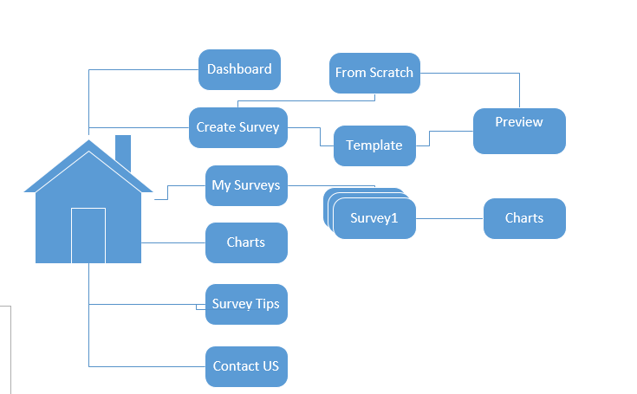

# Wireframes

## Create Survey: Dialog Survey Name and description

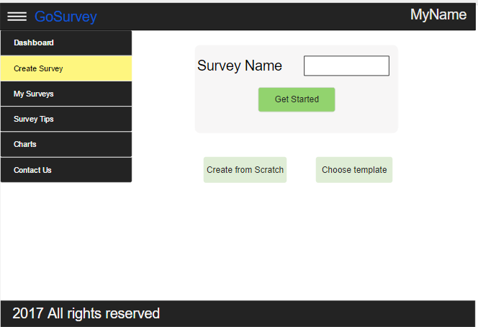

## Create Survey : Multiple Choice

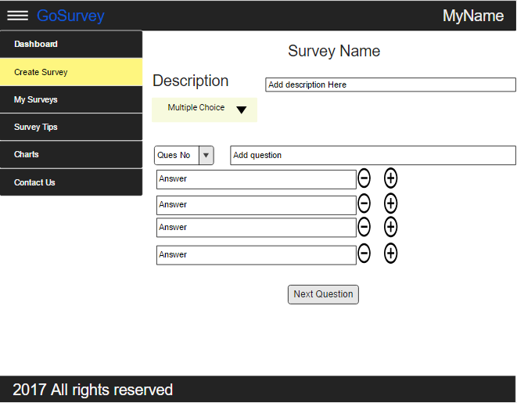

## Create Survey: Short Answer

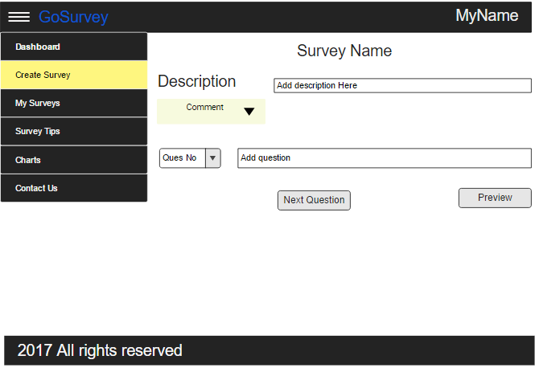

## My Surveys

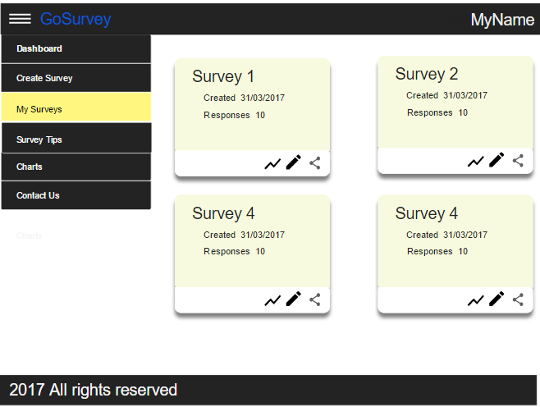

## Analysis : Charts

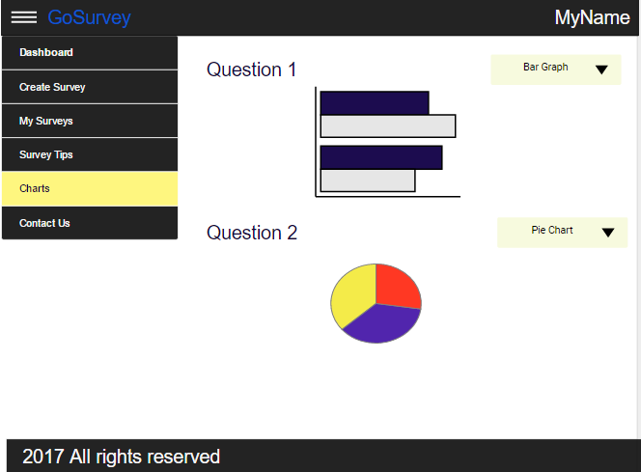

# Potential Future Functionality

* User can sign in using Gmail or Facebook.
* A notifications tab that will notify users about completed surveys and survey lifetimes when they are about to expire.
* Information collected will be easy for analysis. Registered users can export the results to excel/csv format. Registers users can share the analysis reports by email.